Name: B. Krishna
Id: 2400030120
Exp: 3
Sec: 09
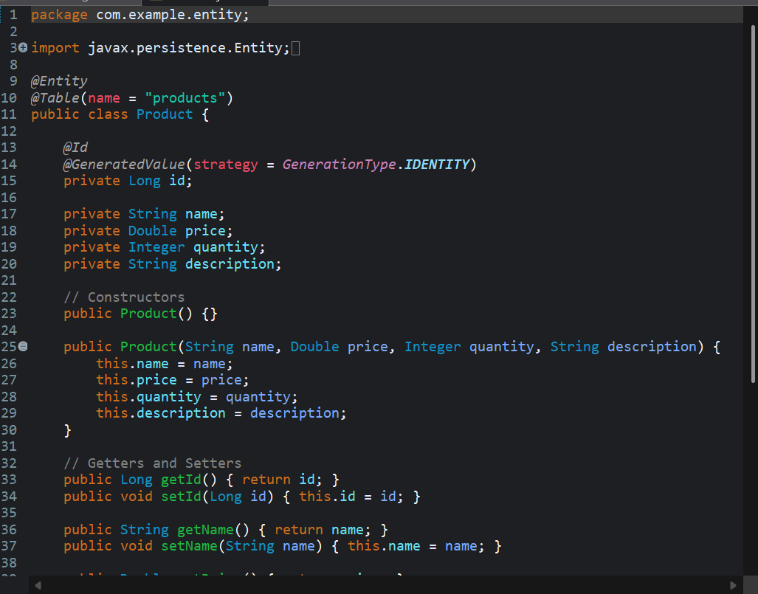
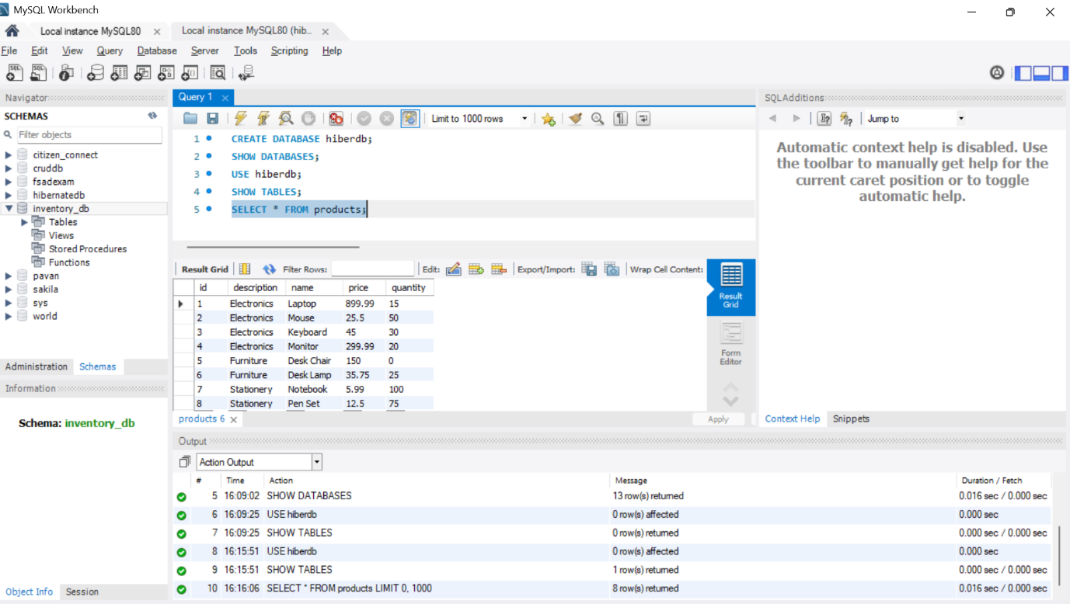

https://github.com/krishna3324/Fsad-Skill.git

